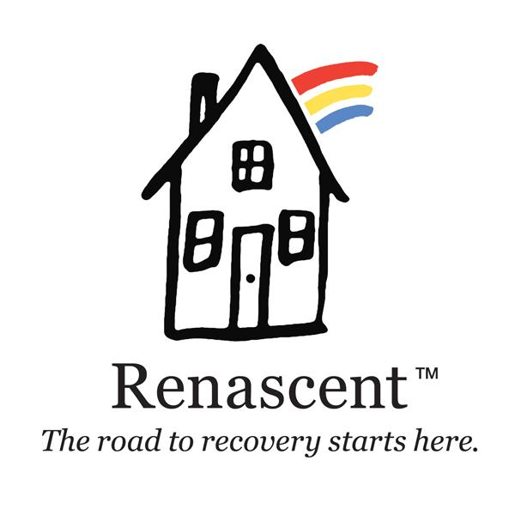

Volunteer Application

My Contact Information
Name
Street Address
City, Province, Postal Code
Home Phone
Work Phone
Email Address

My Availability

During which hours are you available for volunteer assignments?
___Weekday mornings | ___Weekend mornings
___Weekday afternoons | ___Weekend afternoons
___Weekday evenings | ___Weekend evenings

My Personal Interests

In which areas you are interested in volunteering?
Sullivan House ___Addictions Counselling ___ Administration
Munro House ___Peer Support ___Outreach
Punanai House ___ Continuing Care ___Family Program
Wright Center ___Maintenance ___Children’s Program
___ Client Care Access & Engagement ___ Fundraising

My Personal Lived Experience with Recovery
___ Myself | ___Family Member/ Loved One | ___None

My Special Skills or Qualifications

Summarize special skills and qualifications you have acquired from employment, previous volunteer work, or through other activities, including hobbies or sports.

My Previous Volunteer Experience

Summarize your previous volunteer experience.

Agreement and Signature

By submitting this application, I affirm that the facts set forth in it are true and complete. I understand that if I am accepted as a volunteer, any false statements, omissions, or other misrepresentations made by me on this application may result in my immediate dismissal.
Name (printed)
Signature
Date

Our Policy

It is the policy of this organization to provide equal opportunities without regard to race, colour, religion, national origin, gender, sexual preference, age, or disability.

Thank you for completing this application form and for your interest in volunteering with us.

