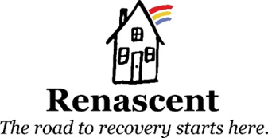

Run or Walk with Renascent on October 16th
Stand against stigma and join Renascent on October 16th at the Scotiabank Toronto Waterfront Marathon 5Km walk/run. We will be raising awareness and funds to support Renascent Foundation and smash the stigma of addiction. You can walk or run a 5k, run a half marathon, or even run the full marathon.

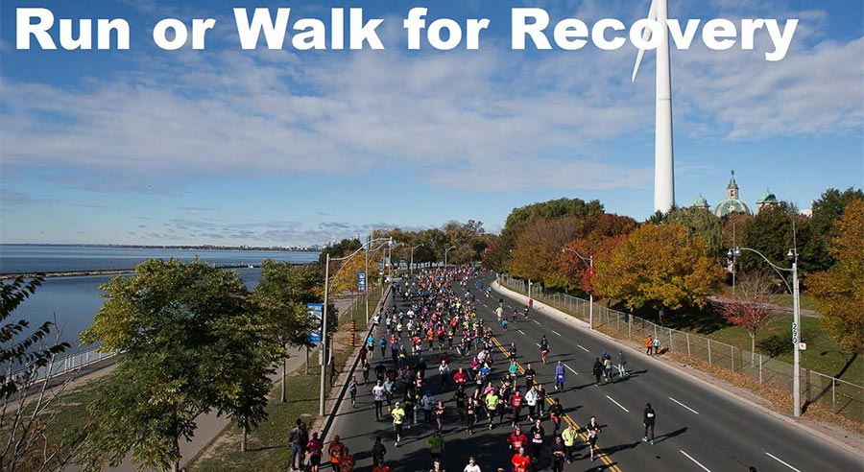

What can you do to support Renascent?
- Walk or Run with us! Raise a minimum of $250 in donations and we will cover your registration fee. Join us for the 5 KM walk or run. If you’re an experienced runner there’s even a half or full marathon!
- Recruit your friends! Running is more fun with the people you love.
- Support a runner! Pledge any amount towards the Renascent Runner in your life.
- Support Renascent! Donate directly and help us provide treatment to those who need us most.
How do I register?
Registering online is easy:
- Visit: https://raceroster.com/events/2016/6374/scotiabank-toronto-waterfront-marathon
Select “Renascent Foundation Inc.” in the Scotiabank Group Charity Challenge section of the application, then choose option “Create a fundraising account” and follow the instructions on screen to register. If you raise more than $250 we will refund your registration fee.
When the application prompts for a code, use: the applicable code for your charity discount. This code is case sensitive.
Use: Marathon or Half Marathon ($80): 16RENF42k
5k ($40): 16RENF5k
5k with Stroller ($50): 16RENFst

- All participants will get a Scotiabank Toronto Waterfront Marathon t-shirt and a Renascent hat!
Join us, wear your shirt and stand proudly with Renascent knowing that you are making a difference!
Questions?
Call or email us at 416-847-6444 or imartins@renascent.ca
“We must open doors, and we must see to it they remain open so that others can pass through.”
Rosemary Brown

